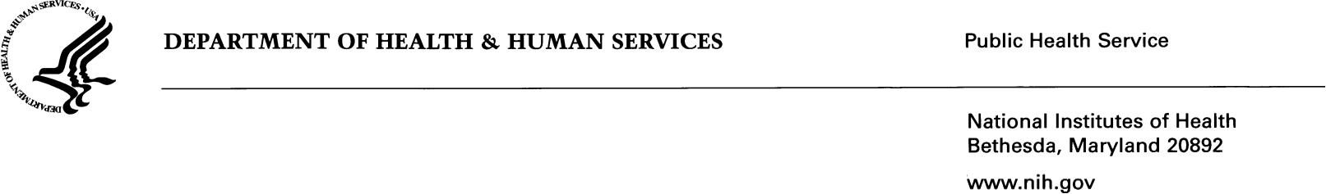

From: [Sender Name] [NIH IC] To: [PI_Full_Name]

CC: [BO_NAME]

Subject:

Date: [DATE PI INFORMED: format Month DD, YYYY]

Dear [PI Salutation],

I am writing regarding [PROJECT TITLE SQL STATEMENT] that was submitted through [RFA_PA_NUMBER]. It has been determined that the application [**Note to author**: Include reason for withdrawal (e.g., is not responsive, does not meet eligibility requirements, etc.)] and will be withdrawn from consideration and not peer reviewed.

(**Note to author:** Provide an explanation as to why the application is being withdrawn. If an application is being withdrawn for nonresponsiveness to the notice of funding opportunity (NOFO), the explanation should identify which of the nonresponsive criteria listed in the published NOFO are relevant. The explanation needs to include a brief summary of what the application proposes and how what is being proposed is nonresponsive to the published NOFO responsiveness criteria.)

For any questions about the withdrawal of this application or if you wish to appeal this decision, please contact (**Note to author:** Provide ICO contact name, Title, NIH Institute, and contact information, email and/or phone number). Please be sure all red text has been removed before submitting ACR.

Sincerely,

[Sender Name]

{Title}

{NIH Institute}

{Phone Number}

{Email} ****Please note that a monitored group mailbox is acceptable.